**Electric Vehicle Drive Simulation**

Using MATLAB/Simulink

Mr. Jay Menon

B. Tech Mechatronics

NMIMS MPSTME

Mumbai, India

menonjay85@gmail.com

# *Abstract*- The paper presents the simulation of a basic electric vehicle motor-drive system that is used to investigate power flow during both motoring and regeneration. The simulation assumes a DC permanent magnet motor, an ideal motor controller combined with a proportional-integral controller, and the electric vehicle battery. The model can be used to evaluate the electric drive’s energy flow and efficiency for specific speed and torque load conditions. Some of the key system parameters were specified and others were modeled as ideal. A stable MATLAB/Simulink model was developed and validated. It was then used to determine the system performance and energy flow over a given set of motoring and regeneration speed/torque conditions. The model could be used to augment instruction in energy conversion or vehicle systems courses.

# INTRODUCTION

This past year electric vehicles were mass produced for the first time in history, and there is a need to include more learning experiences that are related to that topic. “The 2010 – 2020 time period has been described as the upcoming ‘tipping point’ …the

Mr. Aakash Panchagnula

B. Tech Mechatronics

NMIMS MPSTME

Mumbai, India

aakash21012@gmail.com

transition from the Internal Combustion Engine (ICE) as the prime mover of vehicles to electric propulsion systems.”1 “Education is really the important foundation for where the industry is headed in this field.2 Currently there are no ABET accredited Automotive Engineering or Technology degree programs that contain electric vehicle courses3. A literature search for electric vehicle educational revealed a few single-offering or special topics courses,4-9 The Department of Energy has awarded funds under the Advanced Electric Drive Vehicle Education Program to support the development of new courses for graduate, undergraduate, secondary students, teachers, technicians, emergency responders, and the general public.10, 11 However, industry is largely training engineers ‘in-house’, and educational experiences in this technology are needed now to prepare a well trained and educated workforce to support the development of Smart Grid and Electric Vehicle applications.

In addition to the growth in new technology, the design process in industry has also experienced significant change in recent years. Model-Based Design is now commonly used in automotive, aeronautical, and other industries for complex embedded systems.

Traditional design workflow follows a sequential path that involves: a) Requirements

b) Design

c) Implementation, and

d) Test and validation.

Problems with traditional design can develop when:

1) specifications must be read and understood by different engineers on different teams, 2) application engineers have to rewrite design engineers’ algorithms, or 3) the problem is not found until the testing phase.

Model-Based Design uses models early in the process to create executable specifications that allow engineers to immediately validate and verify specifications against the requirements.

Engineers then share models that can demonstrate the performance of the subsystems and components, and also use the automatic code generation capability of Simulink/Real Time and Embedded Coder to facilitate Hardware In the Loop (HIL) testing.

Simulation is a key tool that facilitates design while reducing the cost of product development. As the design process evolves engineers can perform Model-In-The-Loop (MIL), Software-In- The-Loop (SIL), and Hardware-In-The-Loop (HIL) development modeling model is the design. By integrating simulation within the design process engineers can decrease both design costs and design time thus enabling companies to complete and test designed items.

# DRIVE CYCLE

To assist in the design process, vehicle driving tests and vehicle driving simulations are completed to help support the design process to determine if the design is appropriate for the desired application.

A driving cycle is a set of second-by-second set of vehicle velocity values that the simulated vehicle is to attain during the simulation. The need of a drive cycle is to reduce the quantity of expensive on-road tests, and also reduce both the time of test and fatigue of the test engineer. The drive cycle process brings the road to the dynamometer or to the computer simulation.

Drive cycles are used in vehicle simulations to model the drive system and predict the performance of the drive system. There are many standard driving cycles used for testing road vehicles for fuel economy and other purposes. Some driving cycles are developed theoretically, and others are direct measurements of a representative driving pattern. A driving cycle can include frequent speed changes or extended periods at constant speed. An example of vehicle simulator is ADVISOR produced by AVL Engineering16 and other on-line road load and fuel economy simulations.17

# SPEED AND TORQUE VALUES

The simulation that is presented assumes known speed and torque values. If speed values are assumed then the torque values can be calculated if the wheel dimensions are available and the road load values encountered by the vehicle values are known. The total road load is the sum of

he rolling resistance, air resistance, and gradient resistances are known or can be calculated. Information on these calculations is available in literature.18-20

# ELECTRIC VEHICLE DRIVE TRAIN OPERATION

In a typical gasoline powered vehicle the gas tank is not a part of the design model. Gasoline is consumed by the engine, but the engine does not put gasoline back into the gas tank. A paradigm shift from internal combustion engines to electric vehicles is that in an electric vehicle the battery is part of the drive train as shown below in Figure 1: Electric Vehicle Drive Train.

The drive train consumes energy from the battery during motoring. The drive train can also add charge to the battery if the motor is operated as a generator during regeneration. This can occur during braking or if the vehicle is being powered by an Internal Combustion Engine (ICE). In the diagram, the battery is frequently constructed of Lithium Ion cells, and supplies 300+ volts and high current to the power electronics. A battery controller monitors key battery parameters and controls the battery pack.

The power electronics unit inverts the DC battery voltage into three-phase AC voltage at the proper frequency and voltage for the motor to meet the requested speed and torque. The AC motor is typically a high efficiency AC Induction Motor (IM) or Permanent Magnet Synchronous Motor (PMSM). These motors can supply either acceleration torque or braking

torque for both directions of rotation. When the vehicle’s brakes are applied the motor operates in regeneration mode thus reversing both the current direction and torque direction. The reversed torque direction provides vehicle braking torque while helping to recharge the battery.

The Vehicle Interface communicates with the Battery Controller and Motor Controller, and provides an interface with the vehicle-level controls and sensors. Communication between the separate units involves the use of a Controller Area Network (CAN) communications system.

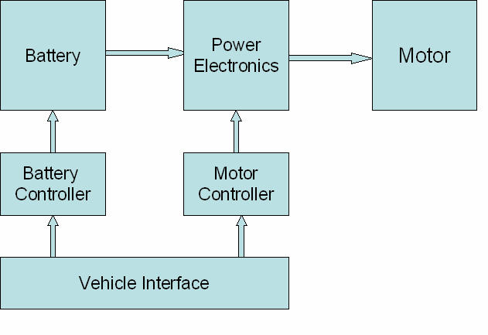

Figure 1: Electric Vehicle Drive Train

# MODEL DEVELOPMENT PROCESS:

The model development process consists of 1) determining how the model will be used, 2) identifying the key equations, parameters, and assumptions, 3) building and refining the model, and then 4) the actual model application and evaluation.

The model can be used to evaluate the energy flow of a DC motor drive train, and to determine the ability of the system to meet specific drive cycle speed and torque requirements. The major components of the model are input road torque, input road speed, motor model, motor controller model, battery model, and PI controller.

A block diagram of the model is presented below in Figure 2: DC Drive Simulation Model. In the model the required Road Speed and Road Torque are inputs, and the major model blocks are the Motor Model, Controller Model, Battery Model, PI Controller Model, and feedback from the PI Controller to the main power controller. The feedback includes a one-sample delay with an initial condition to prevent an algebraic loop in the Simulink mode

Key Equations

Determining the key equations and their corresponding variables and parameters is a necessary first step in model development. Each block in this simplified model represents one or more major equations as listed below.

* *DC Motor:*

As noted earlier, Battery Electric Vehicles (BEV) and Hybrid Electric Vehicles (HEV) frequently use special, high efficiency Permanent Magnet Synchronous Motors (PMSM). This type of motor may be referred to as a brushless DC motor because it runs from DC voltage but does not have brushes. PMSM motors actually use AC voltage that is supplied by the Motor Controller. The motor controller inverts the DC voltage to produce an AC voltage at the proper voltage and frequency. The motor voltage is frequently a 10-20 KHz Pulse Width Modulated AC voltage where the voltage and frequency are adjusted to provide the proper motor speed and magnetic field values.

A DC permanent magnet motor was used in the simulation model presented below. This type of motor is not appropriate for BEV or HEV applications due to weight and efficiency considerations. This motor was used in the simulation because it frequently covered undergraduate engineering education.

The motor model includes some terms and parameters for power loss and time lag while other terms were omitted from the model. The model accounts for power loss in the winding resistance and time lag due to the energy storage in the magnetic field of the winding inductance. There is no field power loss because it is a permanent magnet field.

The model does not include power loss due to friction and other rotational losses of hysteresis, eddy current, and windage. The model also does not include the time lag due to energy storage in the rotor inertia. The motor model is based on the following equations.

Developed Torque is proportional to armature current:

Equation 1:

Td(Nm) = Km*IA(Amp)

[Developed motor torque]

Developed Voltage is proportional to armature speed:

Equation 2:

VD(Volt) = WD (rad/sec)/Km

[Developed motor voltage]

Motor armature input or terminal voltage is equal to the sum of developed voltage plus resistance and inductance voltage drops. In addition, the motor High Side voltage and current are directly connected to, and therefore identical to, the motor controller High Side voltage and current.

Equation 3:

VH(Volt) = IH(Amp)*RA(Ohm) + LH(Henry)*di(t)/dt(A/s) + VD(V)

[Motor Voltage]

Shaft output torque is equal to developed torque minus friction loss (Bw) and inertial loss (J*dw(t)/dt). Friction and inertial were not specified in the model and are assumed equal to zero. Therefore developed torque and output torque are equal in this model. However, the model could be easily modified to include these parameters in the future.

The motor physical constant, Km , is a physical parameter that depends upon the construction of the motor. In the SI system Km has units of (Amp/Nm) or (Volt/(rad/sec)). At the electrical – mechanical interface inside the motor the developed electrical power (P = IA* VD* Km ) is equal to the developed mechanical power (P = Km* Td* WD).

As noted earlier, in the motor model the mechanical friction and inertia as well as the magnetic power losses have been set to zero. Therefore, the power loss will only occur in the armature resistance, and the time lag will only occur in the armature inductance.

* *Motor Controller:*

The motor controller is assumed to be an ideal controller with no power loss and no time lag. The controller simply raises the battery voltage to meet the higher voltage needs of the motor. The dimensionless constant gain or K ratio of the input and output voltages is determined in order to meet the motor’s needs. The same K ratio is used to adjust the current so that input and output power values are equal.

High side voltage is equal to K times the low side voltage:

Equation 4:

VH = K*VL

[Controller High Side Current]

High side current is equal to 1/K times the low side voltage:

Equation 5:

IH = (1/K)*VL

[Controller High Side Voltage]

* *Battery:*

The battery is modeled as a voltage source with an internal resistance. The model accounts for internal power loss in the resistance of the battery. There is no time lag component in the model. The battery is assumed to have a constant internal voltage, EB. The battery terminal voltage, VB, is equal to the sum of the internal voltage and resistance voltage drop. The battery voltage and battery current are equal to the controller low side voltage and current.

Equation 6:

VB (Volt) = IA(Amp) *RA(Ohm) + EB(Volt). [Battery model calculation]

VL (Volt) = IL(Amp) *RA(Ohm) + EB(Volt).

[Assuming: VB = VL and IA = IL]

The battery model uses the current and voltage information from the Motor Controller to calculate the required battery’s internal voltage. This voltage is compared with the actual EB value to create a battery voltage error, BEER, and that error is used by the PI controller model to adjust the loop gain.

Equation 7:

BERR = EB (actual) - EB(calculated)

* Proportional Integral (PI) Controller:

The PI controller accepts the BERR signal from the Battery Model and uses proportional (Kp) and integral (Ki) to calculate the gain K value that is used by the Motor Controller.

Equation 8:

K = ( Kp + s*KI)*BERR [PI Calculation]

The simulation includes eight equations and eight variables.

1. SIMULATION MODEL BLOCKS

* *Motor Model*

The simulation block for the motor includes Equations 1 – 3 for the motor. The block is shown below in Figure 3: Motor Model Block.

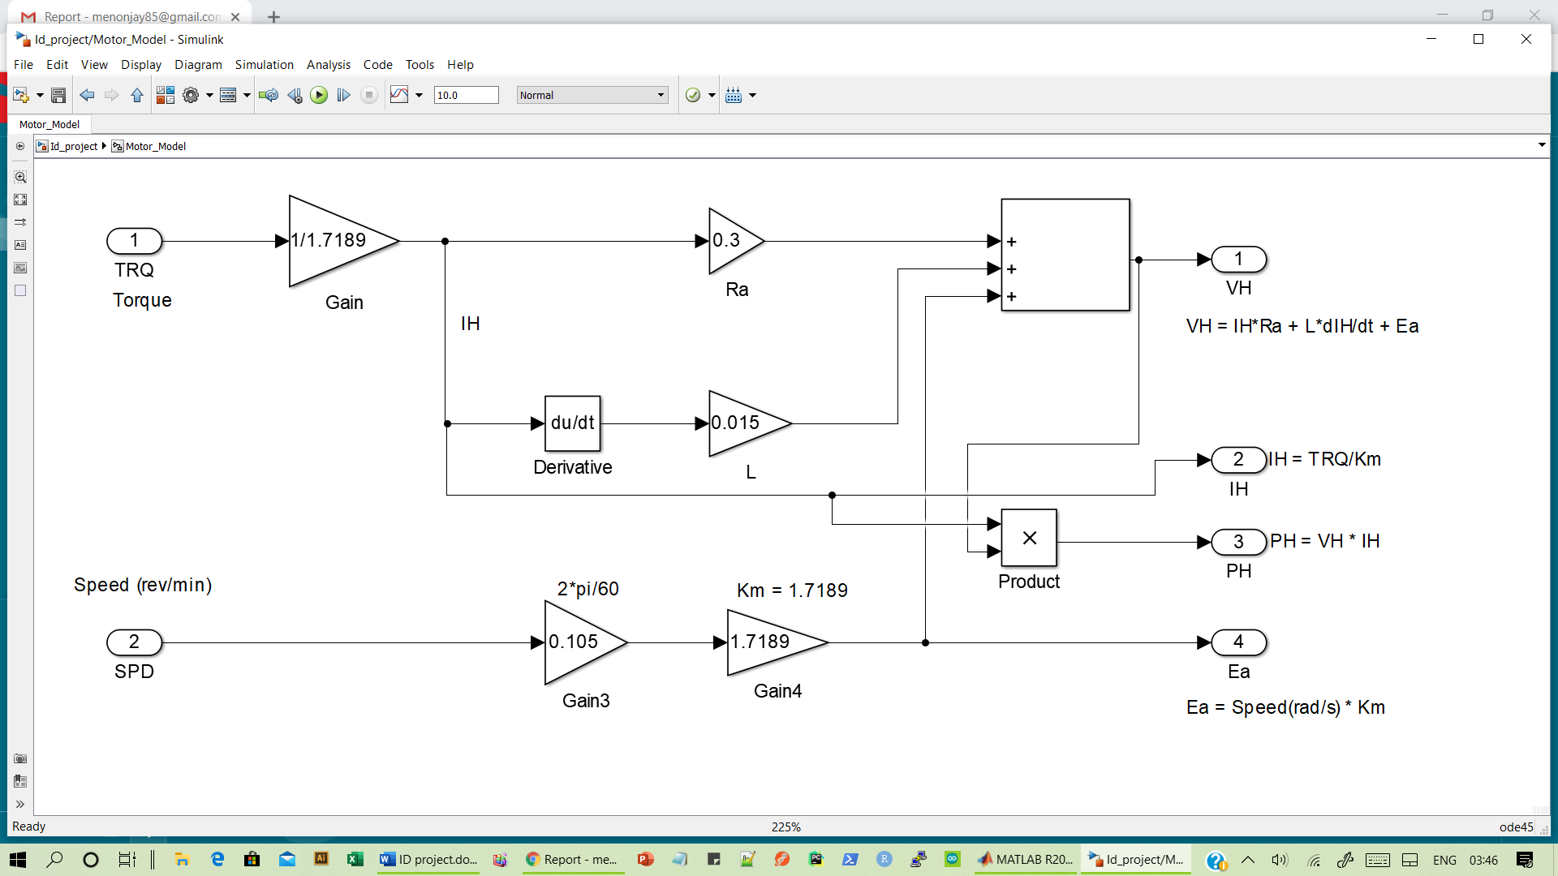

Figure 3: Motor Model Block

* *Motor Controller Model*

The simulation block for the Motor Controller includes Equations 4 and 5 for the motor controller. The block is shown below in Figure 4: Motor Controller Model Block

MOTOR CONTROLLER

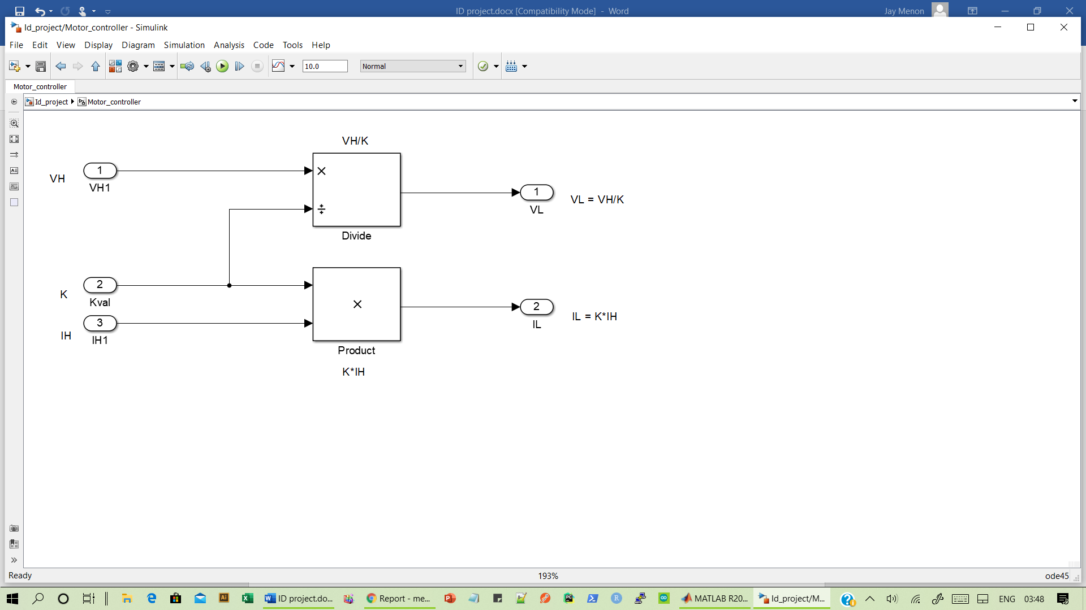

Figure 4: Motor Controller Model Block

* *Battery Model*

The simulation block for the battery model includes Equations 6 & 7 for the battery. The block is shown below.

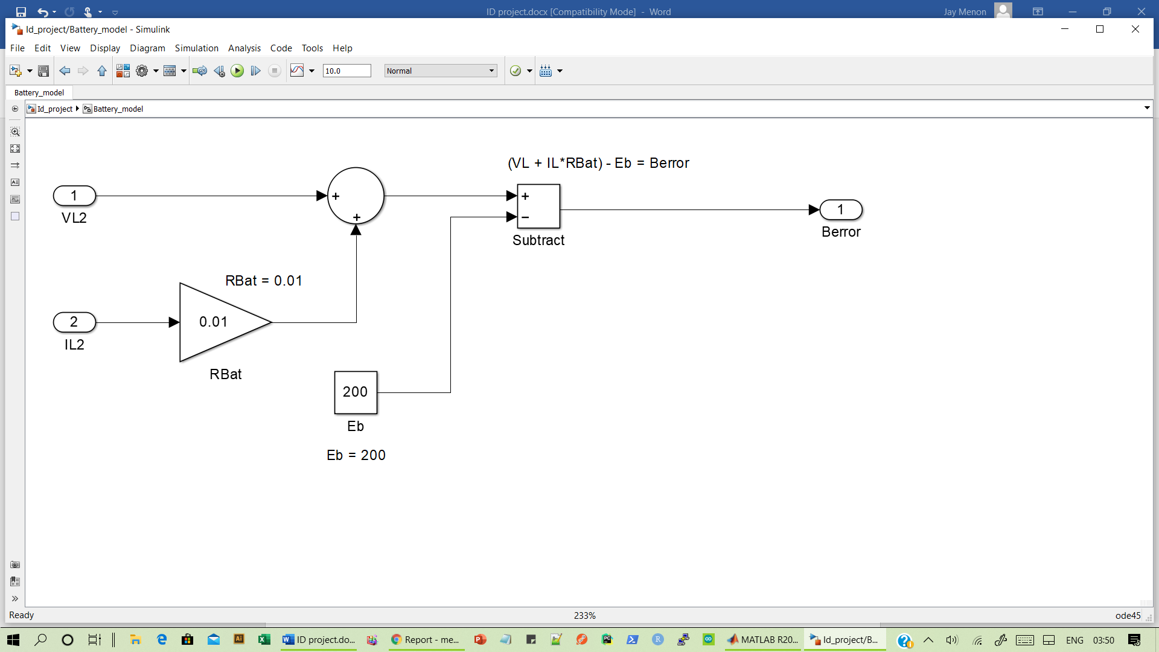

Figure 5: Battery Model Block

* PI Controller Model:

The block model includes Equation 8 for the controller.

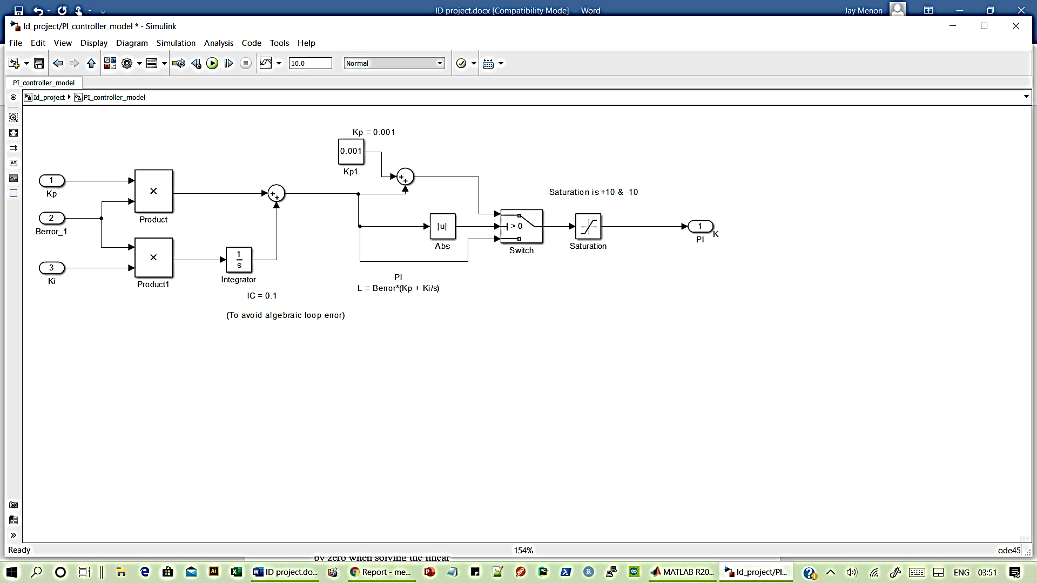

Figure 6: PI Controller Model Block

The Gain (K) of the Motor Controller is determined by the output of the PI Controller model. The gain has an initial starting value of 0.1. This value was preset within the controller’s integration block to minimize the possibility of a Simulink simulation error due to an algebraic loop. An algebraic loop is basically a divide by zero operation when the simulation is trying to solve the set of linear equations.

The PI Controller checks to see that the output is not zero. If the output is zero then the controller outputs a small value ( 0.001). This is done to prevent model analysis failure due to dividing by zero when solving the linear equations. The controller also includes a gain limiting block to prevent excess feedback signals.

The block is shown below in Figure 6: PI Controller Model Block

# BATTERY VOLTAGE, CURRENT AND POWER

The motor draws power from the battery as shown below in Figure 11: Battery Voltage, Current, and Power. As can be seen by comparing Figure 9, Figure 10, and Figure 11, the motor torque, motor current, and battery current curves generally follow each other because torque is

proportional to current. Thus as the torque requirement increases, then the motor must draw more battery current.

* *Motoring and Regeneration*

The Battery Power plot in Figure 11 shows both Motoring and Regeneration. When both current and voltage are positive values then the DC Motor is providing torque in the direction of rotation and power is being transferred to the load. This is normal motoring operation. However, when the motor current is in the opposite polarity of the voltage, then the motor is being pushed and acting as a generator with current flow back into the battery.

* *Battery Energy*

The energy dissipated in motoring and recaptured in regeneration was determined by performing numerical integration of the power curve. Figure 11: Battery Voltage, Current and Power Power (Watt) is to the change of Energy(Joules) with Time (Seconds). Therefore the integral of the power curve is equal to energy in Watt*Seconds. The numerical integration was performed in MATLAB using the trapezoidal rule function, trapz(power,time). The resulting value was then divided by 3600 to get energy in WattHours.

# *Battery Voltage Error (Berr)*

The simulation model adjusts the controller gain (K) to meet drive torque and regeneration requirements. The simulation compared the nominal battery internal voltage, VB =200 volts or VBatt(actual), with a calculated battery voltage based on the motor voltage and current values to get VBatt(calculated). The difference, VBerr, was used as an error signal input to the Proportional Integral (PI) Controller. This VBerr signal was plotted over the range of the simulation operation. This plot is shown below in Figure 12: Battery Voltage Error (BErr).

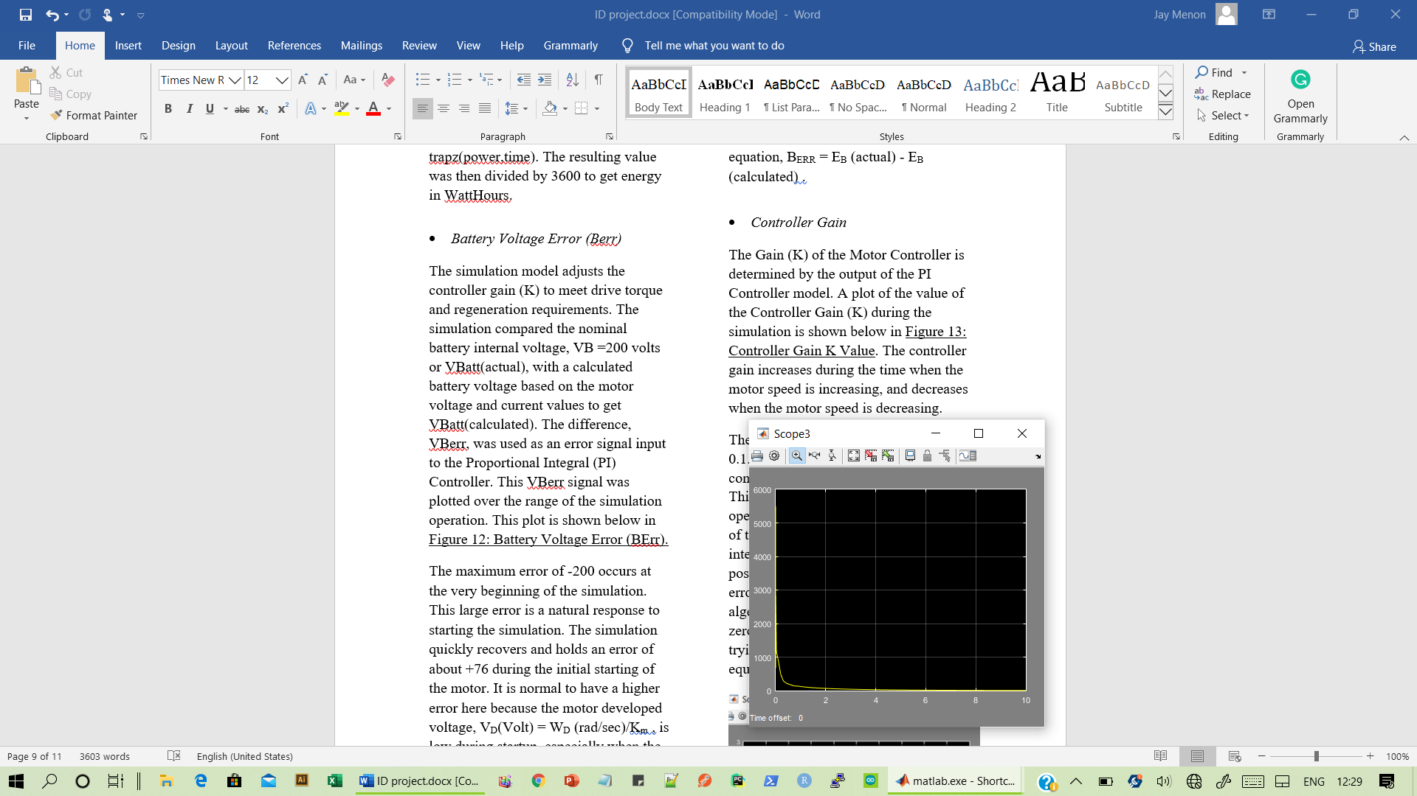

The maximum error of -200 occurs at the very beginning of the simulation. This large error is a natural response to starting the simulation. The simulation quickly recovers and holds an error of about +76 during the initial starting of the motor. It is normal to have a higher error here because the motor developed voltage, VD(Volt) = WD (rad/sec)/Km , is low during startup, especially when the current is increasing.

The negative error occurs during regeneration. By reviewing the motor voltage drop equation, VL (Volt) = IL(Amp) *RA(Ohm) + EB(Volt) , the change in current polarity will cause the reverse polarity of the IL(Amp) *RA(Ohm) term. This voltage change will impact the magnitude of the input and output of the PI controller because of the reduced difference between the calculated and actual voltage in the error equation, BERR = EB (actual) - EB (calculated) .

# *Controller Gain*

The Gain (K) of the Motor Controller is determined by the output of the PI Controller model. A plot of the value of the Controller Gain (K) during the simulation is shown below in Figure 13: Controller Gain K Value. The controller gain increases during the time when the motor speed is increasing, and decreases when the motor speed is decreasing.

The gain has an initial starting value of 0.1. This was preset within the controller in the 1/s integration block. This value is set in the simulation by opening up the 1/s block. The addition of the Initial Condition on the integration block helps to minimize the possibility of a Simulink simulation error due to an algebraic loop. An algebraic loop is basically a divide by zero operation when the simulation is trying to solve the set of linear equations.

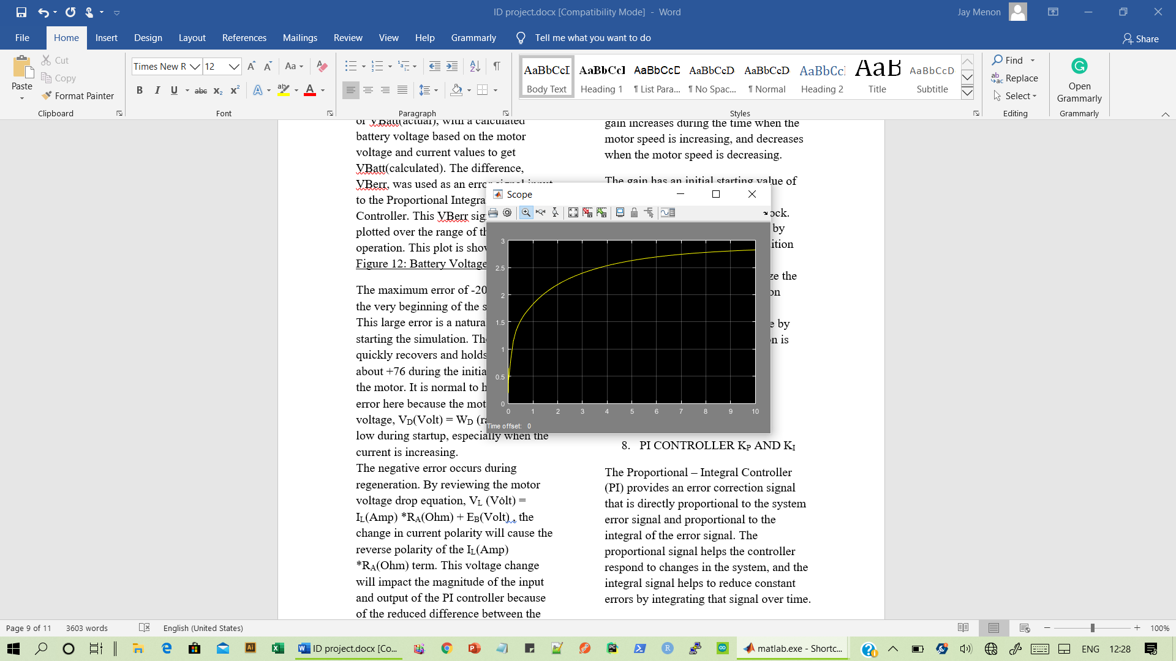

# PI CONTROLLER KP AND KI

The Proportional – Integral Controller (PI) provides an error correction signal that is directly proportional to the system error signal and proportional to the integral of the error signal. The proportional signal helps the controller respond to changes in the system, and the integral signal helps to reduce constant errors by integrating that signal over time.

The Kp (= 0.0001) and Ki (= 0.004) controller constants were determined by trial and error, and the tuning process simply amounted to changing the values while monitoring the magnitude of the Berr signal.

1. SUMMARY:

Simulation is a very real and necessary part of electric vehicle development and needs to be integrated into learning experiences within engineering education. Simulation-based testing in the form of Hardware-In-The-Loop testing is also a very necessary part of current engineering development especially in advanced systems such as hybrid and electric vehicle drive systems that rely heavily on complex embedded system subsystems. Student learning experiences that include simulation based design and testing are necessary to include in undergraduate engineering education in order to prepare students for current industry employment.

**Acknowledgement**:

A portion of the simulation presented here was developed by the authors as part of an open ended project in the course Industrial Drives of semester 6. The course is part of the Mechatronics (B-Tech) graduate degree program at the NMIMS MPSTME, Mumbai. The course was taught by Prof Ainal Abdul Azeez and used various online research papers for reference.

* REFERENCES

1. Smith, Best Practices for Establishing a Model-Based Design Culture, 2007-01-0777, www.mathworks.com
2. Herniter, Combining Passion with Fundamentals – Applying Model-Based Design to Education, Paper 2008-01-1292, www.mathworks.com
3. http://www.virtual-car.org/wheels/wheels-road-load-calculation.html
4. http://www1.eere.energy.gov/vehiclesandfuels/pdfs/success/advisor_simulation_tool.pdf
5. Fundamentals of Vehicle Dynamics, Gillespie, SAE, ISBN 1-56091-199-9 pgs 110-115
6. Hybrid Electric Vehicles, Mi, Masrur & Gao, Wiley, ISBN 978-0-470-74773-5 pgs42-45
7. Electric and Hybrid Vehicles Design Fundamentals 2nd Ed. Iqbal Husain, CEC Press, ISBN: 978- 1-4398-1175-7